

  - School of Data Science And AI: Intelligent Systems

Detecting Model Collapse in Fine-Tuned Large Language Models: An Assessment of Semantic Diversity and Factual Consistency

A research proposal toward the degree of Master of Science in Data Science

Student: Doron Tzur
Supervisor: Dr. Sharon Yalov Handzel
Date: 26/07/2025

Abstract
Large Language Models (LLMs) trained on AI-generated data are prone to model collapse - a progressive degradation in output quality and diversity. This study fine-tunes two models (Llama-3.2-1B and Mistral-7B) on three dataset types: human-generated (WikiText-103), AI-generated (GPT-2-medium), and mixed (50/50), evaluating each using Type-Token Ratio, Bigram Diversity, and Perplexity. AI-trained models showed 16-32% degradation across all diversity metrics (Cohen's d = 9.37), consistent across both architectures. Notably, mixed-trained models preserved or exceeded human-baseline performance, suggesting that 50% human data is sufficient to prevent collapse. These findings provide quantitative, cross-model evidence of collapse and a reproducible detection framework.

Contents
Abstract 2
Introduction 4
Research Question and Hypothesis 4
Research Objectives 5
Literature Review 6
Research Statement 8
Proposed Methodology 9
Data Description 9
Large Language Models (LLMs) 9
Model Training 10
Model Evaluation 11
Comparison of Models 12
Limitations 13
Methodology 14
Phase 1: Setup and Data Preparation 14
Phase 2: Model Training and Initial Testing 16
Phase 3: Evaluation and Metrics 19
Discussion And Planned Work 24
Acknowledgements 25
References 25

Introduction
In the rapidly expanding landscape of Large Language Models (LLMs), a critical threat known as model collapse poses serious risks to their foundational integrity. This degradation occurs when generative models are trained on synthetic, AI-generated data rather than authentic human content, creating a recursive cycle where inaccuracies from one model's output become systematically embedded in subsequent models. The effects are substantial - progressive loss of output diversity and creativity, an increasing tendency toward generic "safe" responses, and critically, the gradual forgetting of real-world data - particularly low-probability events and sparse representations vital for understanding minority groups, rare scenarios, or edge cases.
Prior research consistently shows that generative models trained heavily on synthetic data produce generic outputs and lose critical real-world understanding. This degenerative process, attributed to statistical and functional approximation errors, is considered largely inevitable when models rely excessively on synthetic data across generations. Studies on recursive self-training of LLMs directly demonstrate quality decline, with models becoming biased, repetitive, and losing variety over successive iterations. Despite this growing understanding, a significant gap remains - the current lack of robust, practical methods for detecting and characterizing early signs of model collapse. This paper addresses this challenge by developing practical methods for detecting early signs of model collapse in fine-tuned LLMs through evaluating their semantic diversity, comparing models trained on varying proportions of human and AI-generated datasets to build a robust framework for spotting early warning signs of degradation.

Research Question and Hypothesis
Research Question: Does fine-tuning LLMs on AI-generated data cause measurable degradation in linguistic diversity and generation quality, and does this pattern hold across different model sizes?
Hypothesis: Models fine-tuned on AI-generated data will show significantly lower lexical diversity than human-trained models, with mixed-trained models showing intermediate or no degradation. These patterns will be consistent across both Llama-3.2-1B and Mistral-7B.

Research Objectives
- Construct three controlled datasets: human-generated, AI-generated, and mixed (50/50).
- Fine-tune Llama-3.2-1B and Mistral-7B on each dataset under identical training conditions.
- Apply lexical diversity metrics (TTR, Bigram Diversity) and perplexity to quantify model collapse.
- Quantify degradation across training conditions and compare results across both model architectures.
- Evaluate whether mixed-data training mitigates collapse relative to pure AI-trained models.
- Establish measurable collapse thresholds for early detection.
- Investigate recursive training collapses across multiple generations.

Literature Review
Model collapse is a degenerative process that occurs when generative models are repeatedly trained on data produced by other models, rather than on authentic human-created content.
This creates a degrading cycle where errors compound across generations, resulting in models that produce increasingly generic outputs and lose understanding of real-world patterns, especially rare events and minority cases.
Over time, the tails of the distribution - representing rare or low-probability events-disappear, and model behavior converges toward overly simplified outputs with minimal variance. Importantly, this collapse can occur even without any shift in the underlying data distribution, and it is considered inevitable when models rely too heavily on synthetic data across generations [1].
The root of model collapse lies in two compounding sources of error: statistical approximation error and functional approximation error. The former arises from the limited size of training samples, which often overlook infrequent but important data points. The latter stems from model architectures that are either too simplistic to fully represent the original data or that generate outputs outside the original data's scope.
In experiments using the OPT-125M model fine-tuned on the Wikitext-2 dataset, performance dropped when models were trained on generated data, as reflected by rising perplexity scores compared to those trained on real data. Interestingly, later model generations produced text that seemed more typical to earlier models-indicating a shift toward the average-but also exhibited unusually long perplexity tails, suggesting increasing errors and a loss of grounding in reality. To mitigate model collapse, maintaining access to high-quality, human-generated data is critical. As AI-generated content becomes more common online, distinguishing between human and machine output will be essential for preserving the integrity of future training datasets.
[2] focused on GANs, and showed that training generative models on complex, structured data is inherently prone to instability, and convergence is not guaranteed. These insights are valuable beyond GANs, offering perspective on similar risks in models like large language models (LLMs), especially when they’re fine-tuned on data that may be synthetic or distributionally shifted over time.
The study examined why training Generative Adversarial Networks (GANs) can be unstable and often fail to converge to an optimal solution, known as the Nash equilibrium. This problem becomes particularly apparent when the data and the generator distributions lie on lower-dimensional manifolds-something common in real-world datasets like images or text, where absolute continuity doesn't hold.
One of the central issues identified is that, near the equilibrium point, training can become highly unstable. A clear example is the Dirac-GAN, where the generator and discriminator enter into an endless loop of oscillations instead of settling. This happens because the discriminator's gradients become very steep around the true data distribution, constantly pushing the generator away and preventing convergence. This behavior connects closely to model collapse - where the generator outputs only a narrow range of samples that can fool the discriminator but fail to capture the full diversity of the data.
The investigators tested a range of techniques aimed at stabilizing training. Their results show that methods like instance noise (adding small amounts of Gaussian noise to inputs) and zero-centered gradient penalties (which directly penalize the discriminator’s gradient magnitude) help to improve convergence, at least locally. On the other hand, more popular techniques such as Wasserstein GANs don’t consistently lead to convergence when using a fixed number of discriminator updates per generator update.
[3] focused specifically on the risks of recursive self-training of LLMs.
The study explored whether large language models (LLMs) can effectively improve themselves by training on their own generated outputs. While the idea seemed promising, the authors presented evidence that this kind of self-training can lead to a serious decline in model quality. In this case, model collapse referred to the model's output becoming increasingly biased, repetitive, each round of self-training. The study showed how the quality of the generated text progressively deteriorates, losing variety and becoming more constrained over time.
The researchers fine-tuned a pre-trained GPT-2 model on text it had generated itself. They evaluated performance using standard validation datasets like Wikitext-2 and Penn Treebank. Over multiple self-training iterations, they observed a steady increase in validation loss on real data. At the same time, the model’s loss on its own generated data dropped to near zero, showing it was becoming increasingly good at predicting its own narrow and repetitive outputs.
The paper also examined what factors speed up the collapse. It turns out that a higher learning rate makes the degradation happen faster, and that larger models are more prone to collapse quickly. These findings raise serious concerns about recursive self-training in practice.
A key takeaway is the warning about the future of LLMs. As AI-generated content becomes more widespread online, models trained on synthetic data may inherit the same degradation seen in the experiments. The research pointed out limitations in current model architecture - they aren’t well-equipped to evolve on their own output without quality loss. This makes data provenance and filtering increasingly important.
Recent 2025 work has extended collapse research in important directions. Keisha et al. [5] demonstrated that LLMs under recursive synthetic training maintain surface fluency while factual accuracy deteriorates, reinforcing the need for diversity-based metrics rather than fluency alone. Wang et al. [6] studied collapse across networks of LLMs, showing convergence patterns consistent with single-model findings and validating cross-model evaluation approaches. Schaeffer et al. [7] argue that catastrophic collapse requires unrealistic assumptions but confirms that training on purely synthetic data consistently degrades tail distributions. Amin et al. [8] show that even weak human data in the training mix substantially resists collapse, consistent with our mixed-dataset findings across both Llama and Mistral. While comprehensive benchmarks like HELM [9] evaluate models across multiple dimensions, our study focuses specifically on lexical diversity degradation as an early collapse indicator.

Research Statement
This project examines the phenomenon of model collapse in fine-tuned large language models, a state where models are trained on AI-generated data rather than human-generated content, leading to degradation in performance and output quality. While LLMs demonstrate remarkable capabilities, their susceptibility to model collapse, manifesting as a progressive loss of output diversity and factual grounding, poses a significant challenge, especially as AI-generated content proliferates. Without clear understanding of how collapse occurs, it becomes harder to trust these models, troubleshoot issues, and deploy them in high-stakes situations.
This project aims to bridge the gap between the growing use of LLMs and the current lack of robust methods for detecting and characterizing early signs of model collapse. The core objective is to develop a practical framework for spotting early warning signs of decline in generative model performance by evaluating and measuring semantic diversity and factual consistency. The core question is: How can we measure both the diversity of model outputs and their factual accuracy simultaneously to detect early model collapse?
To address this, the study will involve fine-tuning two large language models, such as Mistral-7B or Llama-3.2-1B, across several training sessions under distinct data conditions: one trained entirely on 100% human-generated data, another on 100% AI-generated data from a different model, and a third on mixed data comprising 50% human-generated and 50% AI-generated content. The performance will be examined using a combination of metrics, including BLEU and BERTSCORE, alongside the investigation and development of new metrics focused on quantifying the degree of lexical diversity and the degree of factual diversity. By comparing the performance of models trained under these varying conditions and leveraging a set of evaluation metrics, this research seeks to provide insights into the mechanisms of model collapse and establish quantifiable measures for its early detection. This research and detection framework will help maintain the quality and reliability of future LLMs, supporting better decision-making and more effective human-AI collaboration.

Proposed Methodology
The purpose of this chapter is to outline the research methods used in this study, which aims to detect early signs of model collapse in fine-tuned large language models by jointly measuring semantic diversity and factuality. This focus is on investigating the impact of training data provenance (human-generated vs. AI-generated) on LLM performance.
This chapter outlines the methodology for acquiring diverse datasets, fine-tuning selected LLMs under various conditions, evaluating their outputs with multiple metrics, and analyzing results to identify reliable indicators of model collapse. The goal is to provide a rigorous approach for investigating the research question and contributing to better understanding of AI systems.

Data Description
To examine the phenomenon of model collapse, diverse text datasets will be utilized, reflecting different origins:
- Human-Generated Data (100%): This dataset will consist solely of high-quality content produced by humans. The selection will prioritize datasets known for their factual accuracy, diversity, and linguistic richness to serve as a strong baseline for optimal model performance.
- AI-Generated Data (100%): This dataset will be created using a different large language model to ensure completely synthetic content. This represents the "contaminating" data expected to cause model collapse, designed to replicate real-world AI outputs that might accidentally enter training data.
- Mixed Data (50%-50%): This dataset will be a balanced combination of human-generated and AI-generated content. This setup is crucial for observing the onset and progression of model collapse under conditions where synthetic data begins to dilute human data.
The precise nature and size of these datasets will be determined during the project's initial phase, depending on model requirements and availability of suitable high-quality human data.

Large Language Models (LLMs)
This research will focus on two large language models (LLMs) suitable for fine-tuning. Potential candidates include models such as Mistral-7B or Llama-3.2-1B, chosen for their accessibility, performance characteristics, and fine-tuning capabilities. The selection will also consider models that allow for transparent observation of fine-tuning effects and output generation.

Model Training
In the training process, the selected LLMs will undergo fine-tuning sessions tailored to the different data conditions as outlined in the project subject:
- Baseline Training (100% Human Data): Each LLM will first be fine-tuned exclusively on the 100% human-generated dataset. This training phase aims to establish a high-quality baseline of model performance, semantic diversity, and factuality, representing the ideal state of an LLM trained on clean, authentic data.
- AI-Driven Collapse Training (100% AI Data): The LLMs will then be fine-tuned entirely on the 100% AI-generated dataset. This phase is designed to simulate model collapse and observe its effects on output quality and distribution.
- Mixed Data Training (50%-50% Mixed Data): Finally, the LLMs will be fine-tuned on the mixed dataset. This scenario will allow for the observation of how partial exposure to AI-generated data influences the model's degradation, potentially revealing early warning signs of collapse.
Each fine-tuning session will maintain consistent hyperparameters (e.g., learning rate, batch size, number of epochs) to ensure that observed differences in model output are primarily attributable to the nature of the training data. Specific prompts and tasks relevant to the evaluation metrics will be used during training and post-training evaluation to elicit comparable model outputs.

Model Evaluation
The evaluation of the fine-tuned LLMs will employ a combination of existing and new metrics to
jointly measure semantic diversity and factuality, trying to detect early signs of model collapse.
Existing Metrics (Semantic Similarity & Quality):
- BLEU (Bilingual Evaluation Understudy): This metric measures the n-gram overlap between generated text and reference human-generated text. A higher BLEU score generally indicates closer resemblance to human references in terms of fluency and adequacy, but it may not fully capture semantic diversity or creativity. A decline in BLEU score, especially against a diverse reference set, could signal reduced output quality.
- BERTSCORE: This metric leverages contextual embeddings from BERT to calculate the similarity between generated and reference sentences. Unlike n-gram based metrics, BERTSCORE can capture semantic nuances beyond exact word matches, providing a more robust measure of semantic quality. A decrease in BERTSCORE could indicate a shift towards semantically generic or less coherent outputs.
New Metrics (Diversity & Factuality):
- Degree of Lexical Diversity
Concept: Lexical diversity measures vocabulary richness in generated text, serving as an early warning system for model collapse. TTR (Type-Token Ratio) measures vocabulary diversity by calculating the ratio of unique words to total words, while syntactic complexity assesses the percentage of sentences containing subordinating conjunctions or relative pronouns. Degrading models increasingly rely on common words and repetitive phrases, creating measurable vocabulary reduction.
Metrics: We'll use multiple measures including TTR for vocabulary diversity, syntactic complexity percentage for sentence structure variety and Lexical Sophistication Index for proportion of rare words. These capture different aspects of how models use language variety and structural complexity.
Evaluation Approach: Generate responses per model using several prompt types (creative writing, technical explanations, factual questions, etc.). Each category targets different vocabulary areas to ensure broad assessment. Responses are processed and compared against human baselines using statistical significance testing.
Detection Thresholds: Collapse indicators include early warning (>15% decrease in two metrics), moderate collapse (>25% TTR decrease), and severe collapse (>40% decrease across metrics). These thresholds enable intervention before complete degradation.
- Degree of Factual Diversity
Concept: Factual diversity combines accuracy of generated facts with breadth of knowledge accessed, serving as a critical indicator of model collapse. Model degradation manifests as increased hallucinations, over-reliance on common facts, and systematic forgetting of rare but accurate information, particularly affecting minority representations and edge cases most vulnerable to collapse.
Metrics: We'll use accuracy rates for factual correctness, hallucination detection for false information identification, entity coverage analysis across rarity levels, and knowledge entropy measures for breadth assessment. These capture different dimensions of how models maintain factual reliability and knowledge diversity.
Evaluation Approach: Generate responses per model using factual prompts covering biographical, historical, and cultural domains. An automated pipeline extracts factual claims and verifies them against knowledge bases (Wikidata, Google Knowledge Graph). Custom datasets target rare facts often lost during collapse, building on established benchmarks like FactScore (contains human-verified facts) and FEVER (contains labeled true/false claims) datasets.
Detection Thresholds: Collapse indicators include early warning (accuracy drops to 70-85% with reduced entity coverage), moderate collapse (accuracy 60-70% with significant knowledge reduction), and severe collapse (accuracy <60% with minimal rare fact retention). These thresholds enable intervention before complete factual degradation.

By jointly analyzing these metrics, particularly observing their trends across different fine-tuning conditions, we aim to establish a framework for detecting the early signs of model collapse. For instance, a simultaneous drop in lexical diversity and factual diversity/accuracy, coupled with altered BLEU/BERTSCORE, would strongly indicate model degradation.

Comparison of Models
The comparison will be based on the performance of these models when fine-tuned on the different data types (100% human, 100% AI, and 50/50 mixed). The objective is to identify how fine-tuning synthetic data leads to the degenerative process of model collapse.
By analyzing the trends in BLEU, BERTSCORE, lexical diversity, and factual consistency across the different training conditions, we can:
- Quantify the decline: Observe the progressive deterioration in output quality, where models become increasingly biased, repetitive, and lose variety and factual grounding.
- Identify early warning signs: Pinpoint the specific metrics that show significant degradation first, thereby building a practical framework for spotting early warning signs of decline in generative model performance.
- Understand the impact of mixed data: Assess if a 50/50 blend of human and AI data can mitigate or delay model collapse.
This comparative analysis will reveal the strengths and weaknesses of different training approaches and how models perform under various data conditions. The findings will demonstrate the impact of training data sources and address the critical need for data filtering as AI-generated content becomes more common online.

Limitations
While this research provides valuable insights into detecting model collapse in fine-tuned large language models, it is important to acknowledge its limitations.
Firstly, the quantification of "semantic diversity" and "factuality" can be challenging. While metrics like BLEU and BERTSCORE provide proxies for semantic similarity and quality, they may not fully capture the nuanced concept of "diversity" in meaning beyond lexical variety. Similarly, precisely measuring "factual diversity" requires methodologies for fact-checking and assessing the range of accurate claims, which can be complex and context-dependent. These metrics, while providing quantitative measures, may not fully capture the subjective nuances of interpretability and quality in human perception.
Secondly, the generalizability of findings to all LLMs and datasets is not guaranteed. The phenomenon of model collapse may vary depending on the specific LLM architecture, its pre-training data, the fine-tuning datasets, and the domain of application. The synthetic AI-generated data used in this study may not perfectly replicate all complexities present in real-world AI-generated content found online.
Lastly, defining the "early signs" of model collapse can be subjective. While quantitative thresholds will be established for metric changes, the precise point at which a model is in "early collapse" may require further validation against human assessment.

Methodology

Phase 1: Setup and Data Preparation
Dataset Creation
- Human Baseline Dataset
We collected high-quality human-generated text from WikiText-103-v1, a standard benchmark dataset consisting of verified Wikipedia articles. The dataset underwent rigorous quality filtering to ensure consistency and reliability:
Selection Criteria:
- Text length: 100-5,000 characters
- Minimum 20 words per sample
- Average sentence length: 5-50 words
- Minimum 2 sentences per sample
Quality Control Measures:
- Removal of wiki markup and special formatting
- Elimination of duplicate content using MD5 hashing
- Exclusion of headers, tables, and non-prose elements
- Validation of grammatical structure
Final Dataset Specifications:
- Total samples: 5,088
- Training set: 4,070 samples (80%)
- Validation set: 509 samples (10%)
- Test set: 509 samples (10%)
- Average vocabulary size: 1,912 unique tokens
- Lexical diversity (Type-Token Ratio): 0.329

- AI-Generated Dataset
To simulate real-world scenarios where AI-generated content may infiltrate training data, we created a synthetic dataset using GPT-2-medium as the generation model.
Using prompts from the human baseline ensures both datasets cover similar topics, allowing us to compare text quality rather than topic differences. This approach mirrors real-world scenarios where AI systems generate content based on human prompts.
Generation Methodology:
- Prompt extraction: First 10-30 words from human baseline samples
- Generation model: GPT-2-medium (345M parameters)
- Sampling parameters:
  - Temperature: 0.8
  - Top-p (nucleus sampling): 0.9
  - Maximum generation length: 200 tokens
- Quality threshold: Minimum 50 characters per generated sample
Final Dataset Specifications:
- Total samples: 3,180
- 80/10/10 train/validation/test split
- Average vocabulary size: 1,373 unique tokens
- Lexical diversity: 0.236
- Mixed Dataset
To evaluate scenarios where human and AI content coexist, we created a balanced mixed dataset. This dataset simulates realistic conditions where AI-generated content has partially infiltrated human-curated corpora, a scenario increasingly relevant as LLM-generated text becomes more prevalent online.
Composition:
- 50% samples from human baseline (randomly sampled)
- 50% samples from AI-generated dataset (randomly sampled)
- Total samples: 6,360
- Random shuffling to eliminate ordering bias
Final Dataset Specifications:
- 80/10/10 train/validation/test split
- Average vocabulary size: 1,865 unique tokens
- Lexical diversity: 0.323
- Balanced representation of both content types

Phase 2: Model Training and Initial Testing
Training Infrastructure
All model training was conducted using Google Colab Pro with NVIDIA A100 GPU (40GB VRAM) to ensure consistent computational environment across all training runs.
Model Selection and Configuration

Llama-3.2-1B
Model Specifications:
- Architecture: Transformer-based decoder
- Parameters: 1 billion
- Context window: 128K tokens
- Training data: Multilingual corpus (knowledge cutoff: December 2023)
- Access: Open-source, no commercial restrictions
Selection Rationale:
- Size efficiency: 1B parameters are large enough to demonstrate model collapse while being small enough to train multiple times within a reasonable budget
- Modern architecture: Recent release (2024) incorporating state-of-the-art training techniques
- Research accessibility: Open weights enable full reproducibility
- Established baseline: Part of widely-studied Llama family with extensive documentation

Mistral-7B-v0.3
Model Specifications:
- Architecture: Transformer-based decoder
- Parameters: 7 billion
- Context window: 32K tokens
- Access: Open-source, no commercial restrictions
Selection Rationale:
- Scale validation: 7B parameters tests whether collapse patterns observed in smaller models generalize to larger ones
- Research accessibility: Open weights enable full reproducibility
- Architectural diversity: Different architecture from Llama enables cross-model comparison

Fine-tuning Method: LoRA (Low-Rank Adaptation)
LoRA enables efficient fine-tuning by training only a small subset of model parameters (0.19%) while keeping the base model unchanged. This reduces computational costs while maintaining performance. Identical LoRA configuration was applied across all three datasets (human, AI, mixed) to ensure that observed differences originated solely from dataset quality rather than training methodology.

Fine-tuning Details:
- Maximum sequence length: 512 tokens
- Input tokenization: Left padding to max length
- Training samples per dataset: ~4,000-5,000
LoRA Configuration:
- Rank (r): 16
- Alpha (scaling factor): 32
- Dropout: 0.05
- Trainable parameters: 13,631,488 (0.19% of total model parameters)
Training Hyperparameters:
- Training epochs: 3
- Learning rate: 2×10⁻⁴
- Per-device batch size: 4
- Gradient accumulation steps: 4 (effective batch size: 16)
- Optimizer: AdamW
- Precision: FP16 mixed precision

Training Sequence
We trained separate model instances on each dataset type, for both Llama-3.2-1B and Mistral-7B-v0.3:
1. Human baseline training: Fine-tuned on human-generated Wikipedia text
2. AI-generated training: Fine-tuned on GPT-2-generated content
3. Mixed dataset training: Fine-tuned on 50/50 human-AI mixture
Each model (Llama and Mistral) was trained independently on all three datasets, starting from its respective pretrained checkpoint, resulting in six trained models. All models converged successfully with steady loss reduction throughout training.

Phase 3: Evaluation and Metrics
Evaluation Framework
To measure the effects of training data quality on model performance, we employed metrics that capture linguistic diversity and generation quality - key indicators of model collapse.
- Lexical Diversity Metrics
Type-Token Ratio (TTR): Measures vocabulary richness by calculating the ratio of unique words (types) to total words (tokens). Higher values indicate greater lexical diversity:
TTR = Number of unique words / Total number of words
Bigram Diversity: Measures phrasal variety by calculating the ratio of unique word pairs to total pairs:
Bigram Diversity = Unique bigrams / Total bigrams
2. Model Certainty (Perplexity)
- Perplexity: Measures the model's branching factor when generating text.
- Significance: In the context of model collapse, a sharp decrease in perplexity suggests the model has converged on a narrow, repetitive distribution, indicating a loss of "knowledge entropy" and creative variance.
- Statistical Analysis
Effect Size (Cohen's d): Quantifies the magnitude of differences between models, with |d| > 0.8 considered a large effect.
Degradation Percentage: Calculates relative decline in metrics from human-trained baseline to AI-trained models:
Degradation (%) = [(Human value - AI value) / Human value] × 100

Evaluation Procedure
- Test Set: 50 prompts consisting of 15-word prefixes extracted from Wikipedia. This ensures topic neutrality and evaluation consistency.
- Generation Parameters:
  - Temperature: 0.8
  - Top-p sampling: 0.9
  - Maximum length: 150 tokens
- Workflow: Completions were generated for all models, metrics were aggregated across the 50-sample output, and statistical comparisons were performed against the Human-trained baseline.
Results Summary

Llama-3.2-1B
Quantitative Findings:
Model | TTR | Vocabulary | Bigram Diversity | Perplexity
Base (Untrained) | 0.3398 | 1811 | 0.7456 | 5.70
Human-trained | 0.3294 | 1912 | 0.7552 | 7.03
AI-trained | 0.2357 | 1373 | 0.5108 | 3.07
Mixed-trained | 0.3234 | 1865 | 0.7324 | 5.19

Key Observations:
- AI-trained models showed severe degradation across all diversity metrics:
  - TTR: 28.4% decline vs. human baseline
  - Vocabulary: 28.2% reduction
  - Bigram diversity: 32.4% decrease
- Distributional Narrowing: The AI-trained model's perplexity dropped significantly (7.03 to 3.07). This confirms that training on synthetic data causes the model to over-index on a simplified, repetitive subset of language.
- The Mixed-trained model showed only marginal degradation, suggesting that even a 50% inclusion of human data can substantially delay the onset of total collapse.
- Effect Size: Comparisons between Human and AI models yielded a Cohen’s d of 9.37. This indicates a large effect size, confirming that the observed collapse is a structural shift rather than a marginal fluctuation.

Mistral-7B-v0.3
Quantitative Findings:
Model | TTR | Vocabulary | Bigram Diversity | Perplexity
Base (Untrained) | 0.3671 | 1839 | 0.7897 | 4.31
Human-trained | 0.3074 | 1739 | 0.7442 | 3.40
AI-trained | 0.2594 | 1359 | 0.5675 | 2.95
Mixed-trained | 0.3151 | 1782 | 0.7617 | 3.33

Key Observations:
- AI-trained models showed consistent degradation across all diversity metrics:
  - TTR: 15.6% decline vs. human baseline
  - Vocabulary: 21.9% reduction
  - Bigram diversity: 23.7% decrease
- Mixed-trained models matched or slightly exceeded human-trained performance across all metrics, suggesting that in larger models, 50% human data is sufficient to fully preserve linguistic diversity.

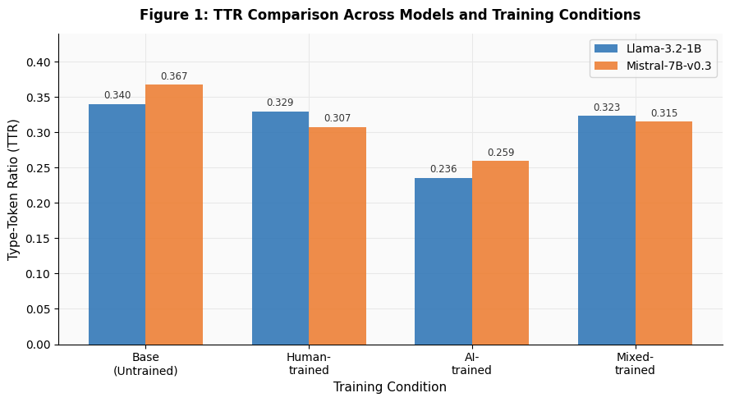
Figure 1: Type-Token Ratio across training conditions. AI-trained models show vocabulary reduction in both architectures, with Llama-3.2-1B showing steeper decline (28.4%) compared to Mistral-7B (15.6%). Mixed-trained models remain close to human baseline.
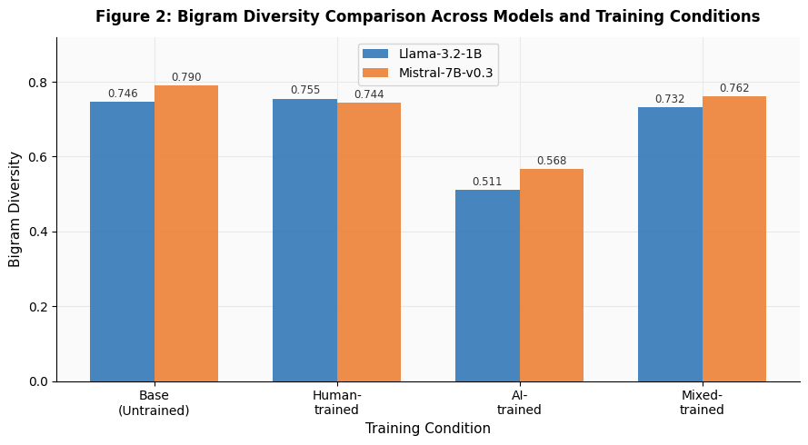
Figure 2: Bigram Diversity across training conditions. AI training causes the sharpest collapse in Llama (32.4%), while Mistral shows moderate decline (23.7%). Mixed-trained models preserve phrasal diversity across both architectures.
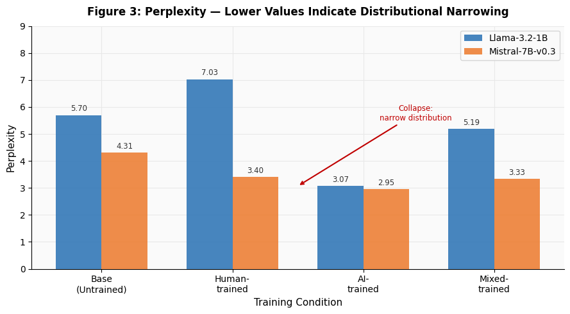
Figure 3: Perplexity across training conditions. A sharp drop in the AI-trained condition indicates distributional narrowing - a key marker of collapse.
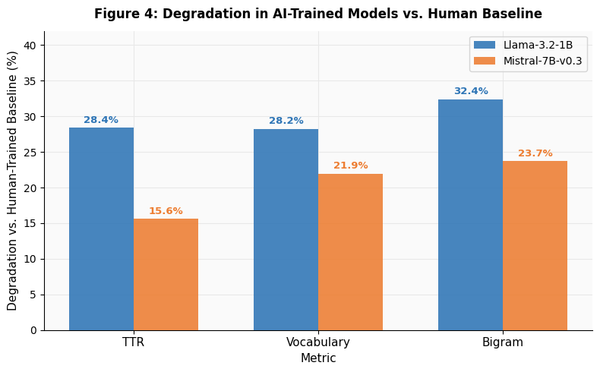 Figure 4: Degradation in AI-trained models vs. human baseline. Llama-3.2-1B degrades more severely, suggesting smaller models are more vulnerable to synthetic training data.

Discussion And Planned Work

Discussion
This study investigated whether fine-tuning LLMs on AI-generated data causes measurable linguistic degradation, and whether these patterns generalize across model sizes. The results consistently confirm the hypothesis: AI-trained models showed significant collapse across all diversity metrics.
A significant finding is the degradation level in Llama-3.2-1B when trained on AI-generated data - a 28-32% decline in lexical diversity metrics (Cohen's d = 9.37), indicating this is a structural shift rather than statistical noise. This aligns with Shumailov et al. [1] and Herel & Mikolov [3], who predicted that synthetic training causes models to over-index on high-probability, repetitive outputs. The sharp perplexity drop (7.03 → 3.07) further confirms that the model became highly "confident" but in a narrower linguistic space.
Mistral-7B showed the same collapse but at a lower magnitude (16-24% degradation), suggesting larger models retain more of their diversity even after fine-tuning on degraded data [5][6]. This finding has practical implications - model scale may guard against collapse but does not prevent it.
The mixed-dataset results are the most novel contribution of this study. In Llama, mixed training showed only marginal degradation relative to human-trained models. In Mistral, mixed training matched or exceeded human-trained performance across all metrics - suggesting that in larger models, 50% human data is sufficient to anchor the model's linguistic distribution and prevent collapse entirely. This is consistent with Amin et al. [8], who showed that even weak human data substantially resists collapse.
These findings have practical implications. As AI-generated content proliferates online, future training datasets will inevitably contain synthetic text. Our results suggest that maintaining even a 50% human data ratio may be sufficient to preserve output quality, a more achievable threshold than filtering all synthetic content.

Planned Work
This phase established the experimental framework and confirmed collapse across two model architectures. The following phases will extend these findings by applying factual diversity metrics (hallucination detection, entity coverage) to complement the lexical analysis, and by executing recursive training experiments - training Gen 2 models on Gen 1 AI output - to test whether collapse accelerates across generations.

Acknowledgements
I would like to express my gratitude to my supervisor, Dr. Sharon Yalov-Handzel (Head of the Intelligent Systems Program, Afeka Academic College of Engineering) for her professional guidance and support throughout this project.
I would also like to thank Afeka Academic College of Engineering for providing the computational resources that supported this research.

References
[1] Shumailov, I., Shumaylov, Z., Zhao, Y., Gal, Y., Papernot, N., & Anderson, R. (2023). The curse of recursion: Training on generated data makes models forget. arXiv preprint. https://arxiv.org/abs/2305.17493
[2] Mescheder, L., Geiger, A., & Nowozin, S. (2018). Which training methods for GANs do actually converge? In Proceedings of the 35th International Conference on Machine Learning (Vol. 80). PMLR. https://arxiv.org/pdf/1801.04406
[3] Herel, D., & Mikolov, T. (2024). Collapse of self-trained language models. arXiv preprint. https://arxiv.org/html/2404.02305v1
[4] CARLA Language Acquisition Center. (n.d.). Activity 4: Lexical complexity and diversity. University of Minnesota. https://archive.carla.umn.edu/learnerlanguage/spn/comp/activity4.html
[5] Keisha, F., Wu, Z., Wang, Z., et al. (2025). Knowledge collapse in LLMs: When fluency survives but facts fail under recursive synthetic training. NeurIPS 2025 Workshop on Evaluating the Evolving LLM Lifecycle. https://arxiv.org/abs/2509.04796
[6] Wang, T., Horiguchi, A., Pang, L., & Priebe, C.E. (2025). LLM Web Dynamics: Tracing model collapse in a network of LLMs.
https://arxiv.org/abs/2506.15690
[7] Schaeffer, R., Kazdan, J., et al. (2025). Position: Model collapse does not mean what you think.
https://arxiv.org/abs/2503.03150
[8] Amin, K., Babakniya, S., Bie, A., et al. (2025). Escaping collapse: The strength of weak data for large language model training.
https://arxiv.org/abs/2502.08924
[9] Liang, P., et al. (2022). Holistic Evaluation of Language Models (HELM).
https://arxiv.org/abs/2211.09110

